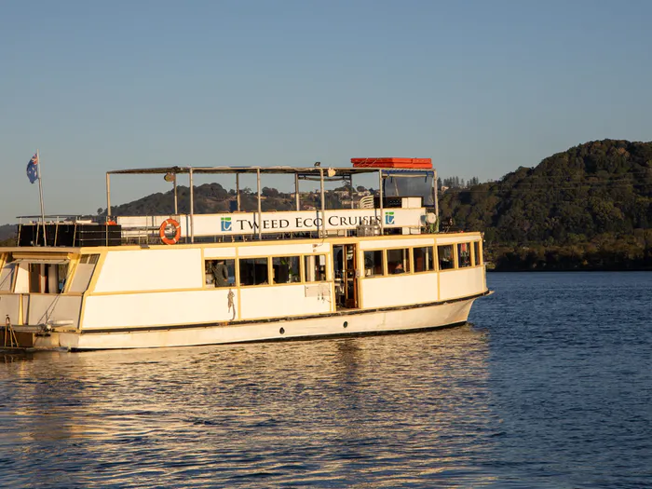
Asbestosis & Mesothelioma Association of Australia Ltd

AMAA Member Tweed River and Rainforest Cruise
Thursday 10th June 2021
Join us for a fun filled group social outing as we embark on a 3.5 hour Tweed Eco Cruise River and Rainforest cruise on the Tweed River- including morning tea and lunch. (11.30am - 3.00pm)
A delicious selection of foods sourced locally from the pristine Northern Rivers NSW region. Enjoy an enlightening commentary on the surrounding areas and history. You are invited to join the shuttle bus at Tweed Heads Bowls Club to take us to the cruise boat.
Only $30.00 per person incl. the cruise, morning tea and a delicious lunch (Vegetarian, gluten free can be arranged)

AMAA would love to see all our members, family and friends join us for this relaxing and fun day.

RESERVE YOUR SEAT TODAY WITH AMAA - RSVP ASAP!
Phone: 1800 017 758 Email: info@asbestosassociation.com.au

